**Comparison of Electric and Traditional Cars**

Electric cars function by plugging into a charge point and taking electricity from the grid. They store the electricity in rechargeable batteries that power an electric motor, which turns the wheels. Electric cars accelerate faster than vehicles with traditional fuel engines – so they feel lighter to drive.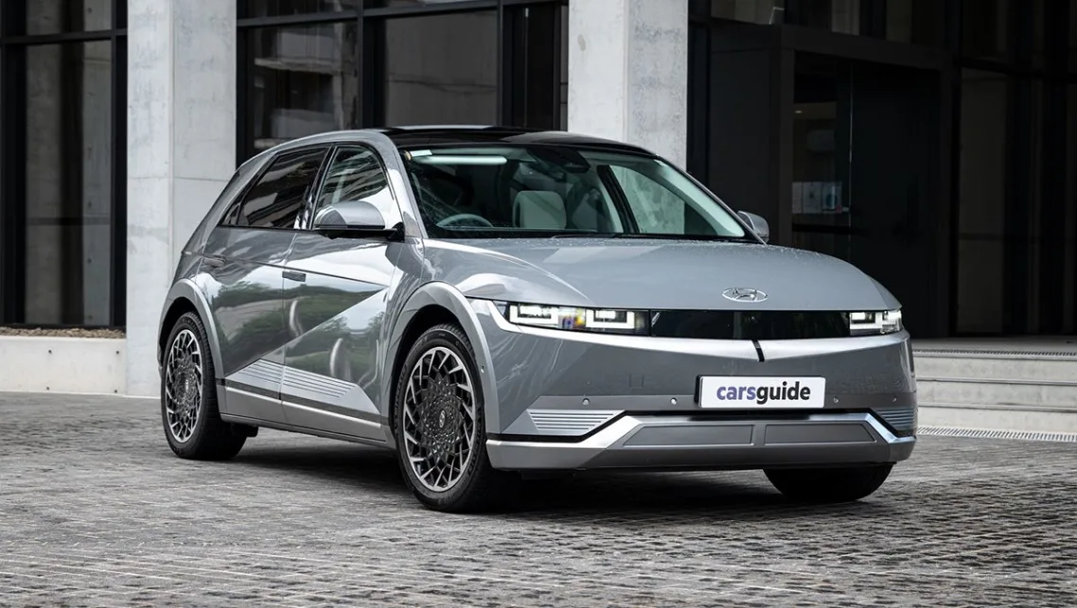Conventional vehicles use an internal combustion engine fuelled by gasoline or diesel to power the wheels. Electricity is used for some accessories, but is not used to move the vehicle**.**

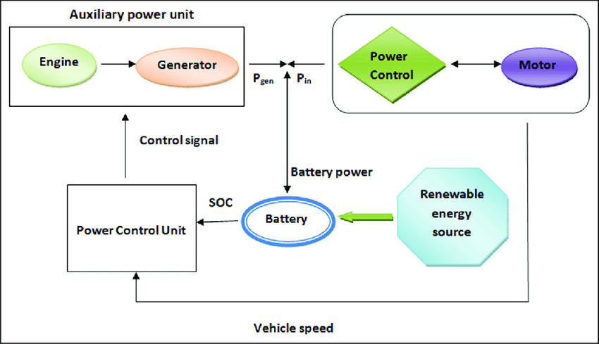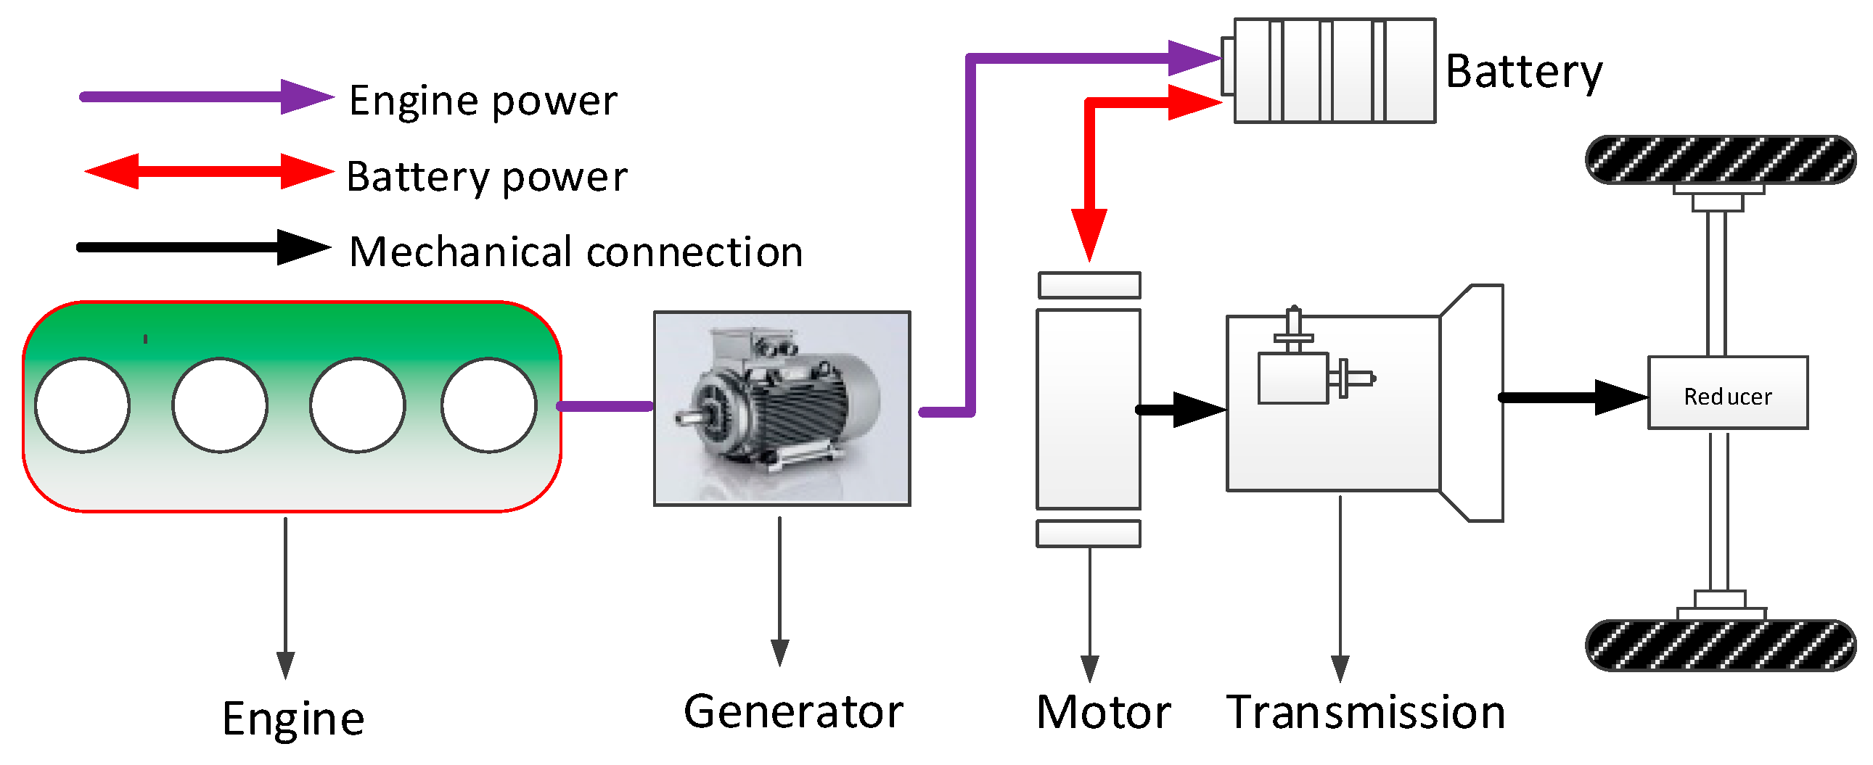 Sulfur oxides and nitrogen oxides are two of the hazardous gases produced when fossil fuels are burned. The NOx and SOx in our environment are a result of ICE vehicles on our roadways. You may lessen the amount of these dangerous gases released into the atmosphere by driving an electric vehicle.

Traditional cars produce significant amounts of CO2 and air pollution. Cars are a large source of nitrogen oxides, carbon monoxide, and particulate matter, which contribute significantly to air pollution. Cars have an environmental impact of 80–90% due to fuel use, air pollution, and greenhouse emissions.

